- A line has a bearing of N 42⁰ 20’ E, a second line has a bearing of S 16⁰ 30’ E. Where the lines intersect, what is the angle of intersection?
  - 26⁰ 20’
  - 59⁰ 0’
  - 110⁰ 00’
  - 121⁰ 10’

- A car travels 28 miles in 40 minutes. How far would the car travel in 4.5 hrs.? Traveling at a constant speed.
  - 154 miles
  - 68 miles
  - 189 miles
  - 126 miles

- x equals
  - X^.5
  - X^4
  - X^2
  - X^-1

- What do you use to place an angle of 53⁰ on a drawing with?
  - Dividers
  - Triangles
  - Protractors
  - Scale

- What does the cotangent of 40⁰ equal?
  - 1/tan(40⁰)
  - 1/cot(55⁰)
  - 1/sin(40⁰)
  - 1/cos(1⁰)

- A building casts a shadow of 20 ft., a boy nearby is 5’ 9” tall and cast a shadow of 2’ 6”. What is the height of the building?
  - 42’
  - 46’
  - 23’
  - 39’

- What does the mixture of a bituminous binder course consist of?
  - Cement and stone
  - Cement, stone, and bituminous
  - Sand, stone, and bituminous
  - Gravel and bituminous

- What do you place first on top of existing old bituminous pavement before you place new bituminous pavement?
  - Carpet
  - Tack coat
  - Surface coat
  - Seal coat

- If more water is added to a concrete mix, the final mix concrete will be
  - More workable
  - Weaker
  - Stronger
  - Denser

- In masonry concrete, the support member over a opening is called?
  - Bridging
  - Parapet
  - Lintel
  - Sill

- A leveling rod in surveying is held in what relationship?
  - Perpendicular to the ground
  - Perpendicular to the plane of sight
  - Parallel to the ground
  - Parallel to the plane of sight

- If a dense fill is required what method is best to use?
  - Compact thick layers with a Sheepfoot Roller
  - Place in thin layers and compact
  - Make sure fill is saturated so compacts well
  - Place by sections ensuring that each section is properly compacted

- In lettering, guide lines are used to control?
  - Height and slant
  - Height and thickness
  - Style and thickness
  - Thickness and slant

- If the subgrade for a road is accidentally excavated to deep, it should be backfilled with which of the following?
  - Concrete
  - Earth
  - Gravel
  - Sandy silt

- In freehand lettering, letters should be placed?
  - Same distance apart
  - So they don’t look bunched or loose
  - Same height but close together
  - Big and bold so people can read them

- What is the structure called at either end of a bridge, which supports the superstructure and retains the earth?
  - Pile
  - Pier
  - Slab
  - Abutment

- A company has a payroll of $6,927.20 which is 60% more than last years’ payroll. What is last years’ payroll?
  - 4,329.50
  - 9,689.08
  - 2,770.88
  - 3,463.60

- A man wants to purchase 12 gallons of gas. At one place the price is 50.9 cents per half gallon, at another place it is 48.4 cents per half gallon. What would he save if he purchased 12 gallons at 48.4 cents per half gallon?
  - .29 cents
  - .30 cents
  - .60 cents
  - $ 1.61

- Given the triangle below, what is the function of AB/BC as a function of angle C?
  - Tan() B
  - Sin()
  - Cos()
  - Cot()
A C
- Where do you look for the width of a bridge?
  - Detail
  - Elevation view
  - Longitudinal section
  - Plan view

- A 100’ tape was used to measure 2500’. Later it was found that the tape was actually 99.96’, What is the length actually measured?
  - 2501’
  - 2499’
  - 2503’
  - 2496’

- A vertical pole is 1/6 in the mud, 3/8 in the water and 33’ in the air. What is the length of the pole?
  - 51’
  - 43’
  - 72’
  - 66’

- You are refinishing a piece of wood, after you remove the old finish, what do you use just prior to placing the new finish?
  - Pumice
  - Soap & Water
  - Sandpaper
  - Paste Wax

- You have just placed new concrete pavement, why would you take pavement cores?
  - Check depth of pavement
  - Check depth of reinforcement
  - Check compressive strength
  - Check for honeycombing

- You are using metal forms. Why would you coat them with an agent?
  - To prevent rust
  - To prevent damage to concrete when removing forms
  - To maintain curing temperature for the concrete
  - So they look pretty

- When dropping curb along the street, what does the term splay refer to?
  - Distance from building to curb
  - The transition through the driveway
  - Pate of drop from the building to the curb
  - Slope from top to bottom of the curb

- What are most street curbs made from?
  - Flagstone
  - Concrete
  - Shale
  - Marble
- The elevation of a benchmark is 21.83’. a level is set up and a rod reading of 9.20’ is obtained on the benchmark. A rod reading of 7.12’ is obtained on a turning point. What is the elevation of the turning point?
  - 12.63’
  - 19.75’
  - 23.91’
  - 28.95’

- What would the result of a rod reading added to a known elevation be?
  - Height of instrument
  - Minus reading
  - Back sight
  - Stadia

- Which lead gives you the darkest line?
  - 00
  - B
  - 1H
  - 2H

- What is the purpose of a transverse joint?
  - To provide a stopping place when paving
  - To prevent random cracking
  - To allow trapped water to escape
  - To prevent vertical displacement of the slabs

- You want to paint 8 rooms 18’ x 22’ x 10’ high. Each room has 2 windows 2’ x 4’ and one door 2’ 6” x 6’ 0”. If the doors are to be painted and two coats are requir4ed for every thing, How many gallons are required if one gallon will cover 450 s.f.?
  - 42
  - 28
  - 30
  - 13

- If a concrete mix is partially hardened before placement into forms, what is the proper procedure to ensure a good final product?
  - Break it up and reuse it in a new mix
  - Add water and remix for 30 revolutions
  - Continue as long as it maintains workability
  - Remove it from the job

- An 80-mm vile is filled ¾ full of liquid. What is the distance from the surface of the liquid to the top of the vile?
  - 60 mm
  - 20 mm
  - 30 mm
  - 18 mm

- A price of something is $189.00. Chris bought it for a 5% discount. Chris then sold it to Greg for a 5% profit. What did Greg pay for it?
  - $183.35
  - $193.00
  - $192.52
  - $192.25
- What is used when a roof butts a vertical wall?
  - Caulk and cricket
  - Flashing and tar
  - Rolled rubber and heat source
  - Cap and flashing

- What does grout consist of?
  - Cement and water
  - Cement and sand
  - Cement, sand and water
  - Cement and stone

- Under drafting room conditions, what material is used to obtain a true-dimensional drawing
  - Acetate film
  - Linen
  - Mylar film
  - Vellum

- What is the most frequent reason for the breakage of a steel tape?
  - Kinking
  - Dirt and dust
  - Throwing it
  - Driving over it

- How is the center line designated on a plan drawing?
  - Short dashes
  - Long dashes
  - Long & short dashes
  - Solid

- Which one of the following is the right definition of rip rap?
  - Vertical brick retaining wall
  - Burlap rapping around a pipe joint
  - Gravel backfill around pipes
  - Stone for stream bank protection

- A lighting plan shows the placement of 5 lights, which are 80’ apart. The distance from the junction box to the first light is 150’. What is the minimum length of electrical wire needed for this run?
  - 550’
  - 1100’
  - 470’
  - 620’

Y1l=8’ 6”
Sta 8+00 o=6’ 0” M.H.3 Y3l= 6’ 0”
0= 4’ 5”
M.H.1 M.H.2
Y2l=4’ 5” M.H.4
o=5’ 2” Sta 12+80

- What is the trunk line length of pipe from M.H.1 to M.H.3
  - 499’
  - 480’
  - 461’
  - 19’

- What does (-7.93 + 3/4) - (-8.27 x .35) + [5/8 – (5.79 x -3.71)] +1.6 =
  - -22.3304
  - +13.6341
  - +19.4204
  - +12.0314

- What is shown in the diagram?

  - Cut and fill cross section
  - Cut cross section
  - Fill cross section
  - Benching

- What causes the failure of neoprene strips in joints?
  - Spalling of the ends of neoprene
  - Squeezing of the neoprene during the expansion process
  - Failure to adhere to both sides of the joint during excessive temperature changes
  - Effects of deicing chemicals

- If a parcel weighing 5.5 lb. is being shipped, how much postage would be required if the first lb. is $.22 and each lb. or fraction of a pound is $.04
  - $ .32
  - $ .42
  - $ .38
  - $ .46

- If copying a drawing with a scale of 1” = 2000’ to one with a scale of 1” = 20’, what instrument is used?
  - Planimeter
  - Oscillography
  - Pantograph
  - Dividers

- In construction of a metal roof which seams are soldered?
  - Standing
  - Flat
  - Edges
  - V-crimps

- When should a building be inspected?
  - Only when a defect is found
  - On a periodic basis
  - When a problem is reported
  - When mandated by town/city ordinances

- Air entraining agents are used primarily for what purpose?
  - Increasing strength
  - Increasing durability
  - Increase workability
  - Decrease setting time

The following paragraphs accompany Questions 54 &55.

In cold weather construction, it is often necessary to heat the materials and to cover the fresh concrete or provide a heated enclosure. The hydration of the cement causes some heat to be generated.
If this heat is retained it raises the temperature of the concrete. The effect of this heat depends largely on the shape and size of the structure. In large members, the heat will be retained longer than in small structures. It is difficult therefore, to set down hard and fast rules to cover all cases. Usually, in cold weather, the concrete in massive structures, such as large dams should have a temp at time of placement of 40⁰ F and in ordinary reinforced concrete, such as buildings, the placing temperature should be about 70⁰ F. in no case should materials be heated to the point that the temperature of the fresh concrete is above 80⁰ F. This results in lower strength
In relatively mild weather, when temperature is generally above 40-45⁰ F, with only short periods below this range, heating only the mixing water usually will be more sufficient to provide the desired temperature in the concrete. More heat units can be stored in the water than in the other materials and it is also the most convenient material to heat. The average specific heat (heat units required to raise the temperature of 1 lb. of material 1⁰ F) of the solid materials may be assumed to be 0.22 compared to 1.00 for water.

- Which of the following statements is most in accordance with the preceding paragraphs?
  - Heating the mixing water alone can never supply a sufficient placing temperature for concrete.
  - Ordinary reinforced concrete for buildings should not be heated to a temperature above 70⁰ F
  - Ordinary concrete can be placed at temperatures below 40⁰ F for large dams.
  - Large structures generally do not require as high a placing temperature for the concrete as do small structures.

- Which of the following statements concerning the heating of the mixing materials is best supported by the preceding paragraphs
  - The average specific heat of a solid materials may be assumed to be 1.00
  - Heat units can more easily be stored in mixing water than other mix materials
  - The lower the specific heat of a mixing material, the less heat units required to raise its temperature
  - When heating mixing water is used, it is not necessary to cover the fresh concrete with a heated enclosure.

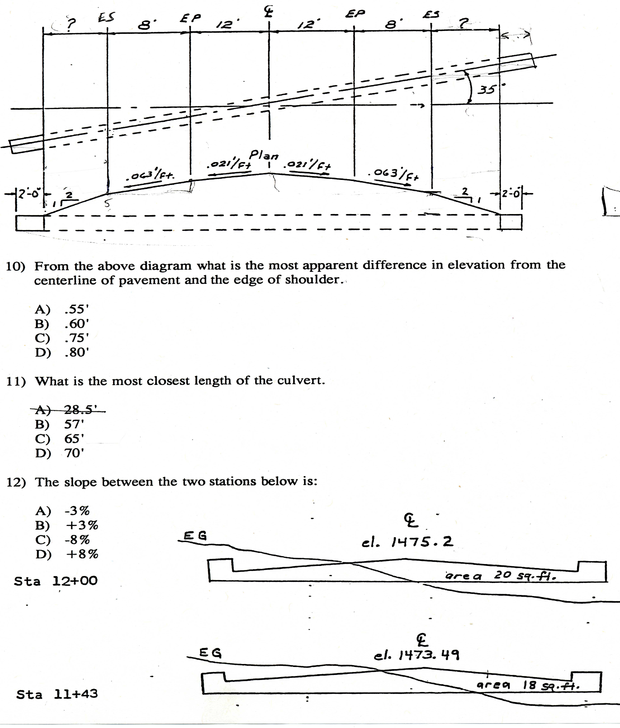

Ele. 100.00’

Ele 96.00’

PET Practice Test 1988 (ANSWERS)

1. D 43. C
2. C 44. C
3. A 45. A
4. C 46. C
5. A 47. B
6. B 48. C
7. C 49. D
8. B 50. B
9. B 51. B
10. C 52. D
11. B 53. B
12. B 54. B Labeled ? 10
13. A 55. A Labeled ? 11
14. C 56. C Labeled ? 12
15. B
16. D
17. A
18. C
19. B
20. D
21. B
22. C
23. C
24. C
25. B
26. D
27. B
28. C
29. A
30. B
31. B
32. B
33. D
34. B
35. C
36. A
37. C
38. C
39. B
40. C
41. D
42. C

